BIOE 301/362 Name:
Exam 1
January 29, 2008

The exam consists of 10 questions. Show all work to receive credit. Clearly organize your work and draw a box around your final answers. NEATNESS COUNTS! Good Luck!

Problem 1 (8):

Problem 2 (10):

Problem 3 (13):

Problem 4 (6):

Problem 5 (8):

Problem 6 (12):

Problem 7 (4):

Problem 8 (8):

Problem 9: (12):

Problem 10 (19):

Total (100):

PROBLEM 1: (8 points total)

A) List the four leading causes of mortality in small children in both the developing and the developed world. (1/2 point each, must be in the correct order)

Developing world: 1) Perinatal conditions; 2) Lower respiratory infections; 3) Diarrheal diseases; 4) Malaria
- Developed world: 1) Perinatal conditions; 2) Congenital anomalies; 3) Lower respiratory infections; 4) Unintentional injuries/accidents

B) Septicemia is a serious infection of the bloodstream that claims the lives of many children in the neonatal period. Two interventions, when used together, have been shown to drastically reduce the incidence of infection following childbirth in the developing world. What are they? (1 point each)

- All births should have a skilled birth attendant present
- Use safe delivery kits including a sterile razor

C) Over 50 million women worldwide suffer from debilitating pregnancy-related conditions. Among them is obstetric fistula. Define obstetric fistula, and describe how this condition impacts a woman’s quality of life. How is it treated? (1 point each)

- Obstetric fistula is an opening between the birth canal and either the bladder or rectum due to injuries received during childbirth. Women are unable to remain continent, and are often left by their husbands and outcast by society.
- A simple and inexpensive surgery repairs the torn tissue.

PROBLEM 2: (10 points total)

Diarrheal illness is a leading cause of mortality in small children in the developing world.

A) In class, we discussed 4 mechanisms of gastrointestinal disease that lead to diarrhea. Describe these 4 mechanisms, and list one potential cause of each. . (1 point each; half-credit given for correct mechanism but incorrect cause)

- Osmotic: inadequate absorption of solutes (lactose intolerance, excess sorbitol ingestion)
- Secretory: excess water secretion into the lumen (bacterial toxins such as cholera, ETEC)
- Inflammatory: damage due to infection (bacteria, viruses, or parasites)
- Motility: accelerated gastrointestinal transit time (diabetes, nerve problems)

B) In the 1960s, a treatment for diarrhea was developed that was soon heralded as, “The most significant medical advance of the century.” What is this treatment, and how does it work? Describe the mechanism in detail. (4 points)

- Oral Rehydration Therapy consists of a solution of water, salt and sugar. When given to patients with secretory diarrhea, such as that caused by cholera toxin, it can prevent dehydration. ORT uses a newly discovered method of sodium transport which depends on glucose. This mechanism is not affected by bacteria which produce diarrhea. Thus, providing glucose can increase sodium transport and promote water absorption.

C) Explain what is meant by the statement, “Malnutrition is an infectious disease.” (2 points)

- Children in the developing world are repeatedly exposed to infectious agents (bacteria, viruses, parasites) that cause the intestinal villi to be blunted, thus reducing the intestinal surface area available for absorption. Over time, their ability to extract nutrients from food sources may be severely compromised.

PROBLEM 3: (13 points total)

A) Sketch a plot showing (1) the HIV viral load and (2) CD4+ T cell count, over the time course of the disease. Clearly label your two curves. On the plot identify the approximate time of the acute phase of the infection, the latent period, and opportunistic infections.

(1 point for each curve, 1 point each for 3 correct labels; 5 points total)

- For the two curves, full credit requires the changes associated with acute HIV syndrome: spike in RNA and dip in CD4 count. Full credit also requires correct overall trends: decreasing CD4 count, increasing RNA copies, and correct labels for the two curves.

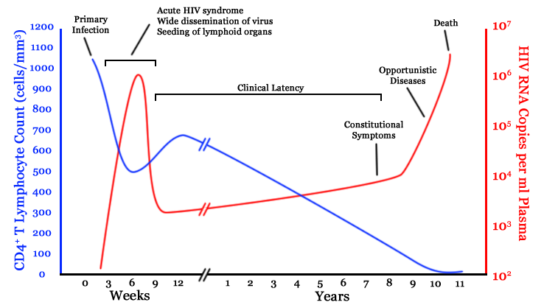

B) Without intervention, an HIV-positive mother can transmit the virus to her baby 30-40% of the time. Describe the 3 routes by which she may transmit the virus to her baby. Then, list the 4 core interventions used to prevent mother to child transmission. What is the risk of the baby contracting HIV if all 4 measures are used correctly? (1/2 point per item, 4 points total)

- 3 routes of transmission: Perenterally (during pregnancy); Perinatally (during delivery); Breast feeding (through milk)
- 4 core interventions: HIV testing and counseling; antiretrovirals to reduce viral load at delivery; safer delivery practices; safer infant feeding (formula).
- These interventions lower the risk to just 4-6%

C) In class, we created a “larger than life” human T cell and HIV particle to illustrate the 8 sequential stages of the HIV life cycle. Identify which of these 8 phases are targets for three major classes of anti-retroviral therapy that have been approved for use. List the general class of antiretroviral drug that corresponds to each of these three phases.

(1 point each)

- Fusion – Fusion inhibitors
- Reverse Transcription – Reverse transcriptase inhibitors
- Integration – Integrase inhibitors
- Assembly – Protease inhibitors
(note: no credit will be given for Tat antagonists: they were not FDA-approved!)

PROBLEM 4: (6 points total)

A) Unintentional injuries are a leading cause of death in the 15-44 year old age group in both developing and developed countries. Most of these deaths are caused by traffic accidents. Beginning with Newton’s second law (F = ma), explain in words and equations how airbags work to save lives.(2 points)

Force = mass x acceleration. Acceleration = dv/dt. (1/2 point each for listing these 2 equations)

Airbags extend the time it takes for a passenger’s head to come to rest during an accident. This decreases acceleration, lessening the force of impact. (1 point)

B) How did our demonstration with the two eggs illustrate these principles? (1 point)

The egg thrown against the wall decelerated rapidly and broke. The egg thrown against the sheet had more time to slow down, so deceleration was lessened, which led to a decreased force of impact.

C) There is a great discrepancy in the number of lives lost to accidents around the world. Do more deaths occur in the developed or the developing world? Why might this be? (3 points)

More deaths due to accidents occur in the developing world (1 point).

Factors include legislation in the developed world (speed limits, seat belt laws, bicycle/motorcycle helmet laws, cell phone bans, etc) (1 point)

Other factors include technological advances in the developed world (airbags, seatbelts, crumple zones, child restraints) which may not be available in many developing parts of the world. (1 point)

PROBLEM 5: (8 points total)

A) Describe the sequential steps by which a normal cell in the human body leads to development of a metastatic tumor.

½ point each for including any of the following in the correct order, up to 4 points total:
- Clonal expansion/growth/diversification from one transformed cell
- Metastatic subclone
- Adhesion to and invasion of basement membrane
- Passage through extracellular matrix
- Penetrating and entering the blood or lymph vessels (AKA intravasation)
- Interaction with/hiding from the host lymphoid cells
- Tumor cell embolus
- Adhesion to the basement membrane
- Penetrating and exiting the blood or lymph vessels (AKA extravasation)
- Metastatic deposit

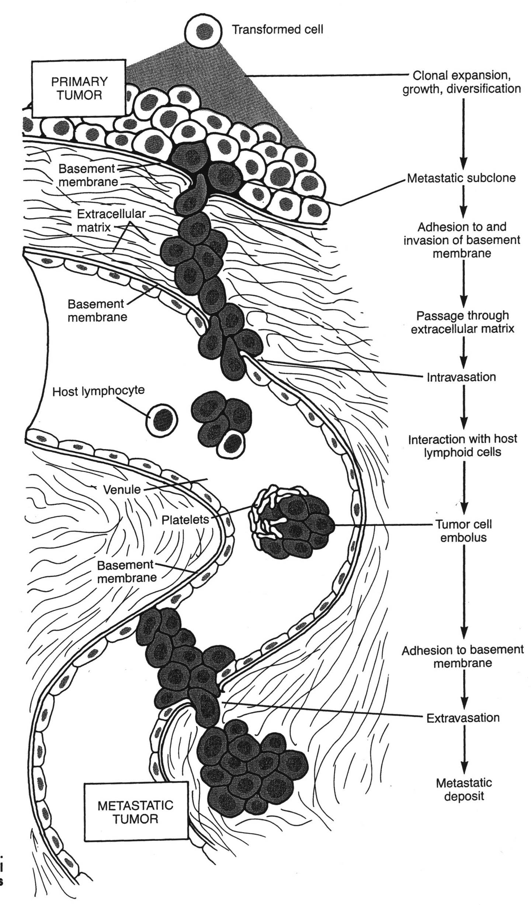

B) Treatment for most cancers currently consists of three interventions: surgery, radiation, and chemotherapy. Why is surgery not always successful? And why are such terrible side effects associated with radiation and chemotherapy? (2 points)

Surgery to remove a tumor often misses small metastatic deposits that have already begun to grow elsewhere in the body. (1 point)

Radiation and chemotherapy kill not only malignant tumors, but all rapidly dividing cells, including hair follicles, GI tract epithelium, bone marrow, etc. (1 point)

C) It has recently been shown that several types of infectious diseases can lead to cancer. List two of these infections, along with the type of cancer that they produce.

(2 points possible -- ½ point for each infectious agent, up to 2, and ½ point for the correctly paired cancer, up to 2)

HPV (human papilloma virus) – cervical cancer
H. pylori (Helicobacter pylori) – stomach cancer
HBV (hepatitis B virus) OR HCV (hepatitis C virus) – liver cancer

Although not discussed in class, credit would also be given for the following:
Epstein-Barr virus—Burkitt lymphoma
HTLV-1—T cell leukemia
HIV—lymphoma, or HIV—Kaposi sarcoma, would be acceptable as well

PROBLEM 6: (12 points total)

Cardiovascular disease is the leading cause of death in the United States in the 45-60 year age range.

A) The two main types of cardiovascular disease are ischemic heart disease and cerebrovascular disease. Define both of these terms. (1 point each)

- Ischemic heart disease refers to problems (angina, heart attack) caused by inadequate perfusion to the heart, usually due to atherosclerosis in the coronary arteries.
- Cerebrovascular disease refers to problems (stroke, TIA) caused by lack of blood flow to the brain.

B) Describe the sequence of events that gives rise to a heart attack.

(1 point each, maximum 6 points possible)

- Endothelial injury (due to high blood pressure, high cholesterol, smoking) is the initial step.
- Fatty deposits build up under the surface of the blood vessel.
- A fibrous cap and necrotic core then form. This begins to narrow the lumen of the blood vessel.
- Unstable plaques rupture, and the substance beneath the surface causes a blood clot to form.
- The blood clot suddenly blocks off the artery, and no blood flows to the heart muscle.
- The heart muscle begins to die due to inadequate blood flow
- If the patient survives the heart attack, the affected heart muscle is replaced by scar tissue.
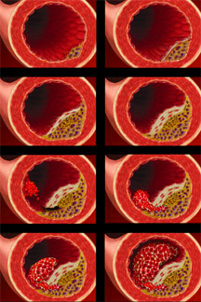

C) Describe two major procedures used in the treatment of ischemic heart disease.
. (2 points each)

- PTCA (Percutaneous Transluminal Coronary Angioplasty): a stent is inserted into the femoral artery and threaded upward into the coronary artery. When it reaches the atherosclerotic lesion, a balloon inflates, pressing a stent outwards against the wall of the artery. This opens the coronary artery and prevents the atherosclerotic plaque from growing.
- CABG (Coronary Artery Bypass Graft): in this procedure, the chest wall is opened and a vein harvested from the patient’s leg is grafted from the aorta to a site just downstream of the blockage, effectively “bypassing” the diseased portion of the artery.

PROBLEM 7: (4 points total)

Two scientists want to know if a certain drug is effective against high blood pressure. The first scientist wants to give the drug to 1,000 people with high blood pressure and see how many experience lower blood pressure levels. The second wants to give the drug to 500 people with high blood pressure and not give the drug to another 500 people with high blood pressure and see how many people in both groups experience lower blood pressure.

  - What is the better way to test this drug?

The second way. (2 pts)

  - Why is it better to test the drug this way?

Presence of control group (2 pts)
PROBLEM 8: (8 points total)

The data in the table below were adapted from the WHO World Health Report, 2005.

Area/Region | Under 5 Population (000) | Total # of under 5 deaths (000) | # of under 5 deaths (000) due to:
 |  |  | Measles | Malaria | Diarrheal diseases | Neonatal Causes | Acute Respiratory Diseases | Injuries
Africa | 110,944 | 4,396 | 227 | 802 | 701 | 1,148 | 924 | 76
Canada and USA | 22,978 | 50 | 0 | 0 | 0 | 29 | 1 | 5
South East Asia | 178,987 | 3,070 | 103 | 12 | 552 | 1,362 | 590 | 71
Europe (Low mortality states) | 22,050 | 25 | 0 | 0 | 0 | 14 | 0 | 2

Based on the information provided for each area/region calculate:

  - The total under 5 mortality rates for Africa and Europe.

Africa= total under 5/total population=4396/110994 (2 pts)
Europe= total under 5/total population=25/22,050 (2 pts)

  - What are some of the factors that account for the difference in the under 5 mortality rates in Africa and Europe?

- Healthcare access (hospitals, doctors, medicine, neonatal care)
- Healthcare costs
- Social/cultural practices
- Regulations/government interventions

2 pts per reason, up to 4 points
PROBLEM 9: (12 points total)

What are the 5 principles of the Canadian health care system?

Comprehensiveness, universality, portability, accessibility, public administration
(1 pt each for total 5 points)

What does it mean for a country to have a two-tier system of health care?

Anything along the following lines gets 2 pts: In exchange for an extra fee, facilities offer quicker access to medicare-insured services. Access if you have resources. Balance of private and public health care options.

Contrast the degree to which the US and Canada have two-tier systems of health care.

US is two-tier. Canada is one-tier, but has seen pressure to move to two-tier. (3 points)

How might this differ in a developing country?

Government can’t afford to cover much healthcare so most people pay out-of-pocket. (1 pt)
There is little or no health-care system (little access), so most people don’t receive care. (1pt)

PROBLEM 10: (19 points total)

What are the two main functions of a health system?
(1) Improve the health of a population (2) in a way that is fair and responsible. (ex: equal service to all, protective, affordable)
(4 pts, 2 per function)

Select one of the candidates who currently running in the US Presidential election. Provide a brief description of this candidate’s proposals to reform the US health care system. Describe whether you believe the candidate’s proposal will improve the ability of the US health system to perform the two main functions listed above.

For all answers: 2 pts per candidate choice, 7 points for description, 6 points for relating to both functions (3 per function). Below is a list of things to be discussed for some of the major candidates.

Clinton—universal healthcare; American Health Choices Plan; people keep their insurance if they like it, or switch to a government offered plan similar to what federal employees receive; affordable, available, portable; collaboration between employers, government, and labor organizations; tax credits for working families; choice; good for small businesses; insurance companies can’t refuse coverage.

Obama—affordable, comprehensive, portable; required for children; National Health Insurance Exchange; preserve and improve Medicare and Medicaid; similar plan to the one federal employees have; guaranteed eligibility; employer contribution; less paperwork.

Edwards—more affordable for uninsured; more options; business must cover or finance employees; competition between public and private insurance; decrease administrative costs; tax credits; expand Medicare and SCHIP; eventually require all to get insurance; regional health care markets.

Giuliani—competing private insurance companies; reward states with innovative ideas; against universal health care.

Romney—competition among private companies; free market, federalist approach; deregulate state insurance markets; no frivolous malpractice lawsuits; tax deductible; stop free care (ER).

Paul—no government involvement in health care; government leads to long waiting, less choice, poorer quality care; all expenses tax deductible; private insurance.

Thompson—let states reform Medicaid; health and wellness instead of illness and disease; cut costs with IT improvements.

